LIB SPACE
Team ID : SWTID-2026-5714
Team Size : 4
Team Leader : Reena. P
Team member : Rohini. J
Team member : Preethika. L
Team member : Sabiha. S

Key Objectives :
- Manage Book Data
To develop a backend system that allows adding, updating, deleting, and retrieving book information stored in the database.
- User Management
To create a system that manages user accounts such as registration, login, and maintaining user details.
- Book Issue and Return Management
To handle the process of issuing books to users and recording book returns efficiently.
- Database Management
To store and manage library data (books, users, transactions) securely using a structured database.
- Search and Retrieval
To provide backend functionality for searching books by title, author, or category.
- Authentication and Authorization
To ensure secure access by implementing login authentication and role-based access (admin or user).
- API Development
To create APIs that allow the frontend of Libspace to communicate with the backend and fetch or update data.
- Error Handling and Data Validation
To ensure the system handles errors properly and validates user input before storing it in the database
Software requirements
1.Backend Framework
Express.js (for Node.js) or Django / Flask (for Python)
2.Database
MongoDB / MySQL / PostgreSQL for storing library data
3.Package Manager
NPM (Node Package Manager) for installing required libraries
4.Code Editor / IDE
Visual Studio Code or any other development
5.Version Control System
Git for managing project versions.
Users flowchart
Start
|
v
Open Libspace System
|
v
User Login / Register
|
v
Search Book
|
v
Check Book Availability
|
v
Issue / Borrow Book
|
v
Return Book
|
v
Update Database
|
v
End
Using the thunderclient in the VS code for registration
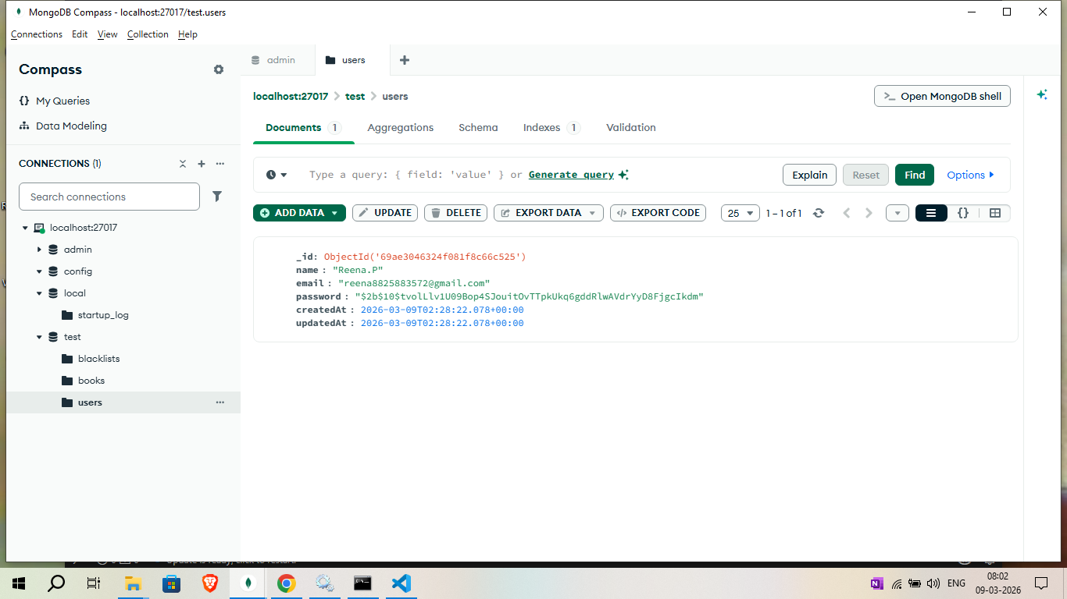
Using the thunderclient for login
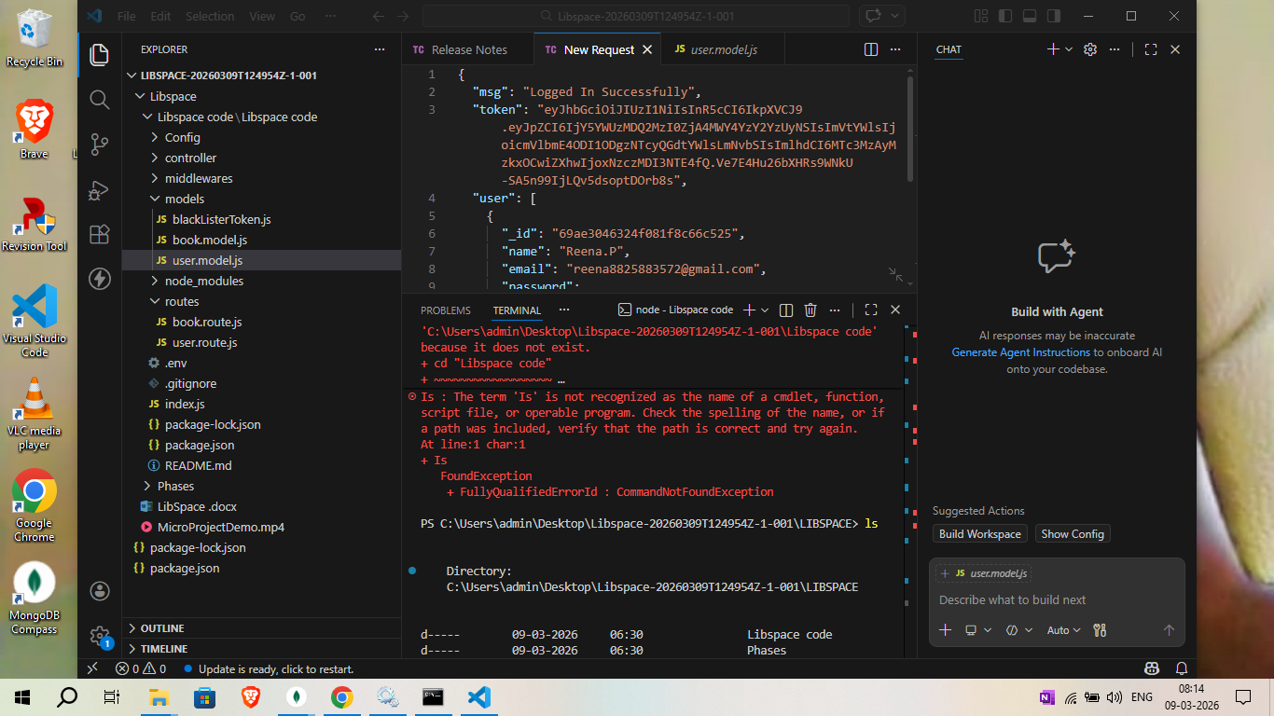

Conclusion:

The Libspace project helps manage library activities in a simple and efficient way. It allows users to search, issue, and return books while storing all records in a database. The system reduces manual work and improves accuracy in managing library data. Overall, Libspace makes library management faster, organized, and user-friendly. 📚

